24ADI204 - Data Science & Visualization
Team Number: 18
Week-02 Report
Data Understanding & Quality Assessment
Project: House Price Analysis and Dashboard

1. Activity / Milestone
This week focused on understanding the structure and quality of the housing dataset. The objective was to identify the data types, missing values, duplicate records and invalid entries that must be corrected before analysis.

2. Dataset Description
The dataset has 4,675 rows and 18 columns. Thirteen columns are numerical (price, bedrooms, bathrooms, sqft_living, sqft_lot, floors, waterfront, view, condition, sqft_above, sqft_basement, yr_built, yr_renovated) and five are categorical (date, street, city, statezip, country). The sale dates fall between May and July 2014.

3. Data Quality Summary
Pandas functions were used to check the shape, data types, missing values, duplicates and basic statistics of every column.
GITHUB REPOSITORY LINK:
https://github.com/wahith628-cmyk/Housing-
COLAB NOTEBOOK LINK:
https://colab.research.google.com/drive/1KAtVlM3go3ssdov3AtYui318LcVl_YK9
DATASET LINK (KAGGLE):
https://www.kaggle.com/datasets/ananthaselvane/housing-dataset
Metric | Value
Total Records | 4,675
Numerical / Categorical Columns | 13 / 5
Total Missing Values | 1,219
Duplicate Rows | 75
Average Price | 554,575
Highest Price | 26,590,000
Lowest Price | 0
Column with Most Missing Values | sqft_living (107 values, 2.29%)

4. Code Implementation
Python and Pandas were used to explore the dataset. The code checks the shape and data types, separates numerical and categorical columns, counts missing values and duplicates, and prepares a summary of the statistics and the missing-data percentage.
CODE SCREENSHOT (Structure and data types):
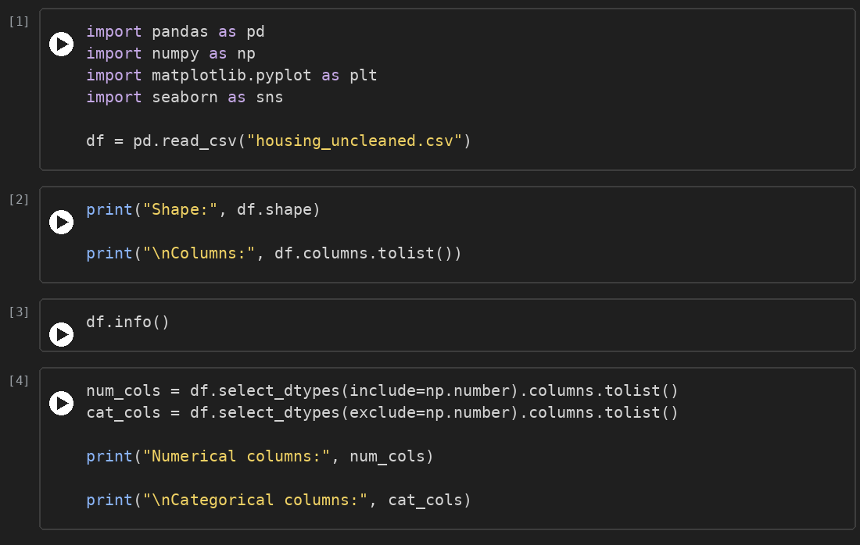
OUTPUT:
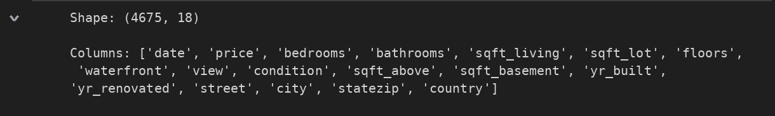
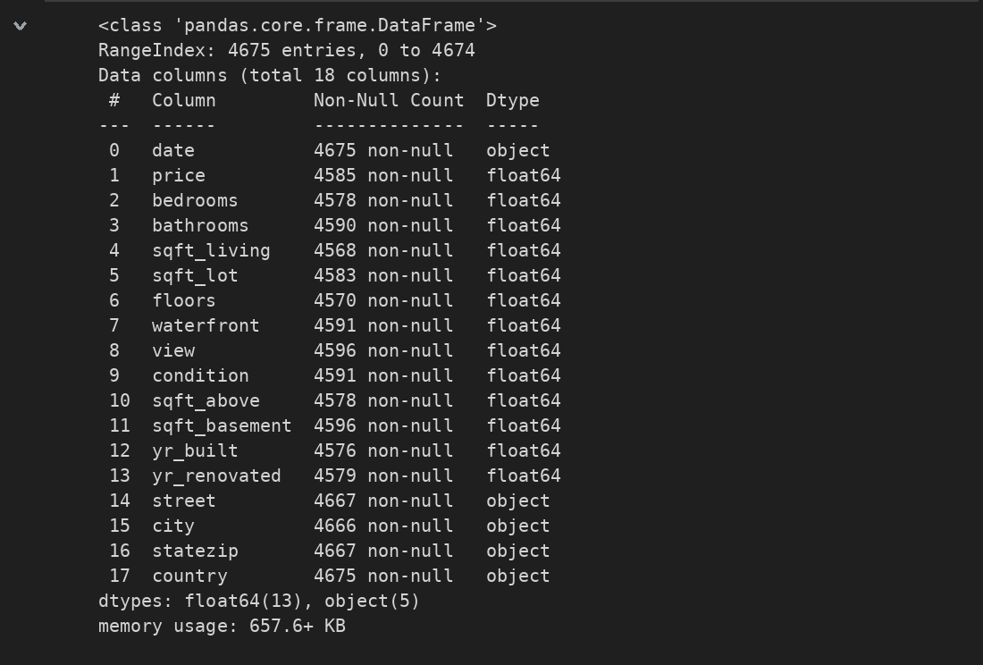
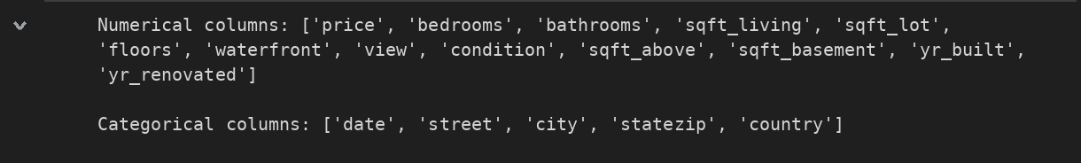
CODE SCREENSHOT (Missing values and duplicates):
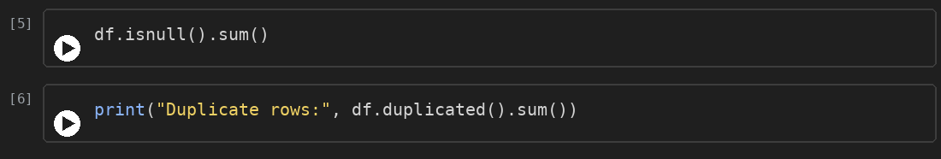
OUTPUT:
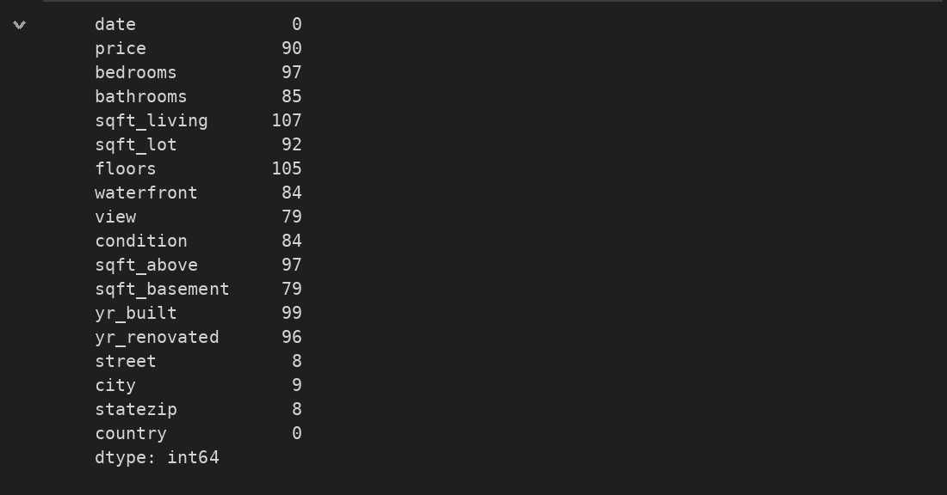
CODE SCREENSHOT (Statistics and missing percentage):
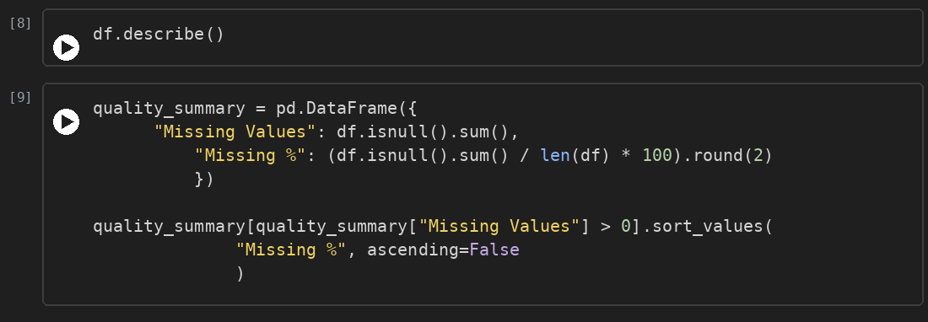
OUTPUT:
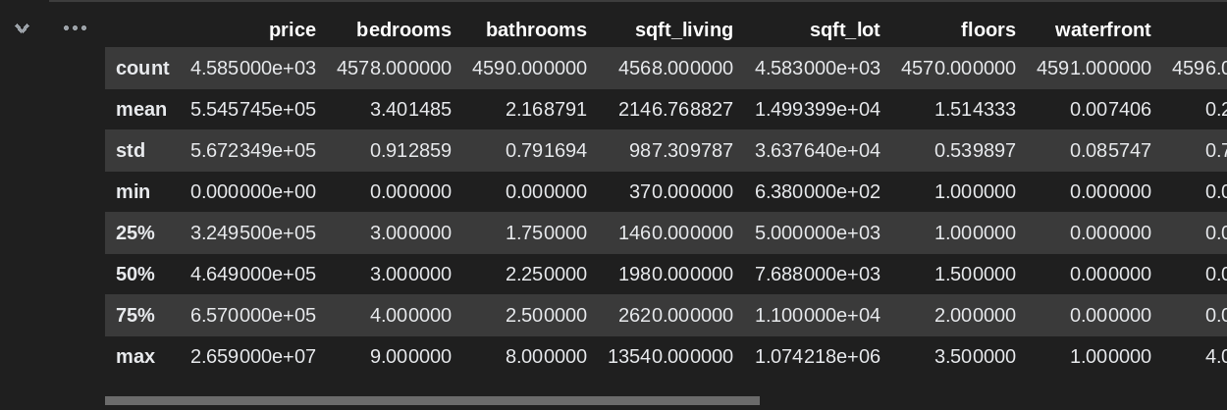
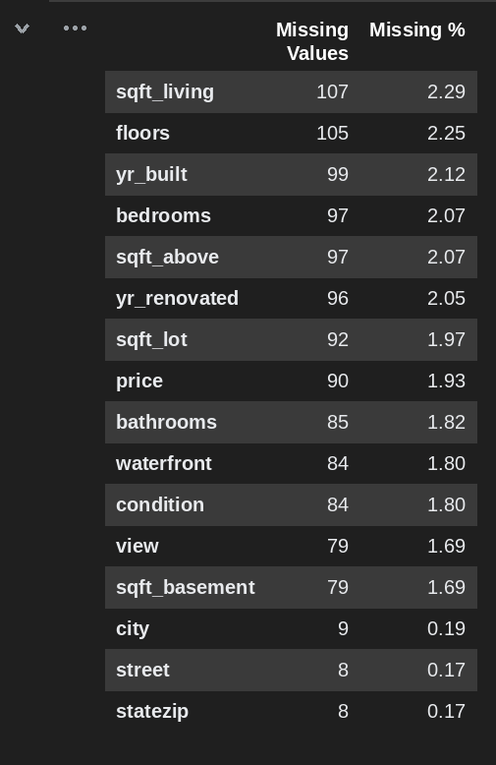

5. Screenshots & Error Handling
The checks showed several data quality issues in the raw dataset. These were recorded in the table below and will be corrected in Week 3.
Data Quality Issues Identified:
Issue | Column(s) | Observation | Planned Handling
Missing values | 16 of 18 columns (all except date and country) | 1,219 missing cells; 79 to 107 per numerical column | Median / mode imputation
Duplicate records | All columns | 75 duplicate rows (1.6%) | Remove duplicates
Invalid zero values | price, bedrooms, bathrooms | Minimum value is 0 | Review and filter
Extreme price | price | Maximum 26.59M against a median of about 465K | Check as outlier
Date stored as text | date | Data type is object | Convert to datetime

Key Insights:
- Missing data is low in every column (at most 2.29%), so no column has to be dropped.
- Price is right-skewed: the mean (554,575) is higher than the median (464,900).
- Less than 1% of the houses are on the waterfront, and the median of yr_renovated is 0, which means most houses were never renovated.
- Zero values in price, bedrooms and bathrooms are invalid and need treatment.

6. Team Contributions
Team Member | Working | Outcome
Inban S | Data Engineer | Documented the findings and compiled the Week 2 report
Abdul Wahith M | Data Analyst | Analysed missing values, duplicates and summary statistics
Dharshan P | Visualization Expert | Prepared the data quality summary and identified the columns to visualise
Anantha Selvan E | Story Teller | Loaded the dataset and checked its shape, data types and column lists

